**Module-1: EBS Assignment**

**Problem Statement:**

You work for XYZ Corporation. Your corporation wants to launch a new web-based application using AWS Virtual Machines, configure the resources accordingly with appropriate storage for the tasks.

**You are asked to perform the following tasks:**

1. Launch a Linux EC2 instance.

2. Create an EBS volume with 20 GB of storage and attach it to the created EC2 instance.

3. Resize the attached volume and make sure it reflects in the connected instance.

**Problem 1 Solution:** Launch a Linux EC2 instance.

**Step 1: Go** to **Services section** & **search “EC2”. Click** on **EC2>Instances.**

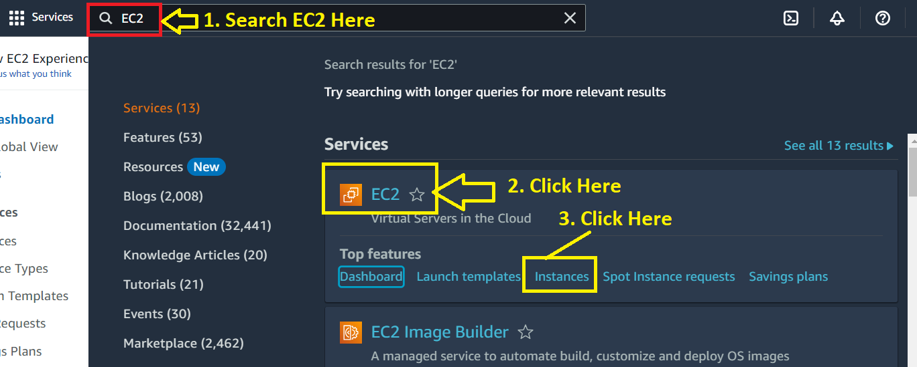

**Step 2: Click** on **“Launch Instance”.**

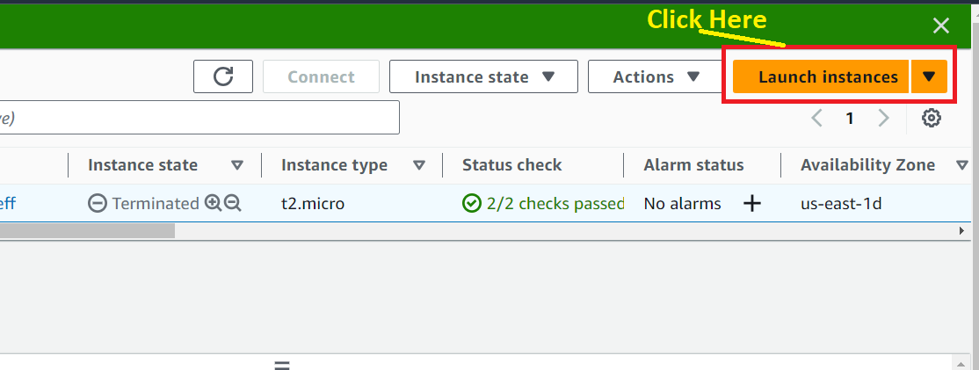

**Step 3: In Name and tags, put** the **Name** as “**EBS_Assignment”.**

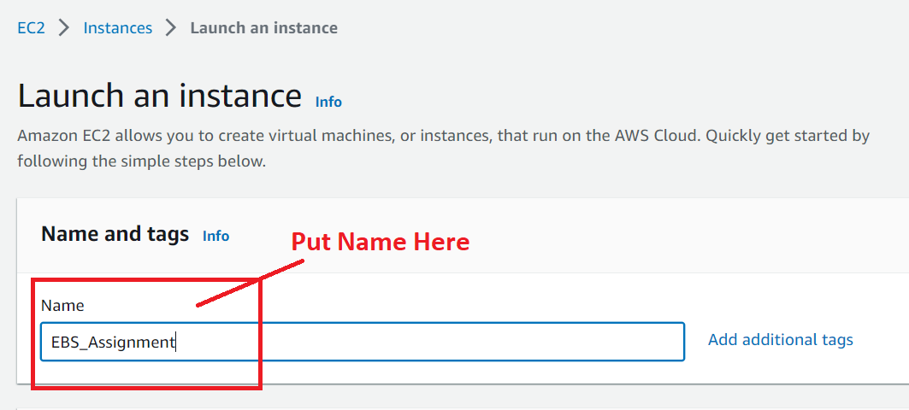

**Step 4: Choose AMI** as **“Amazon Linux”.**

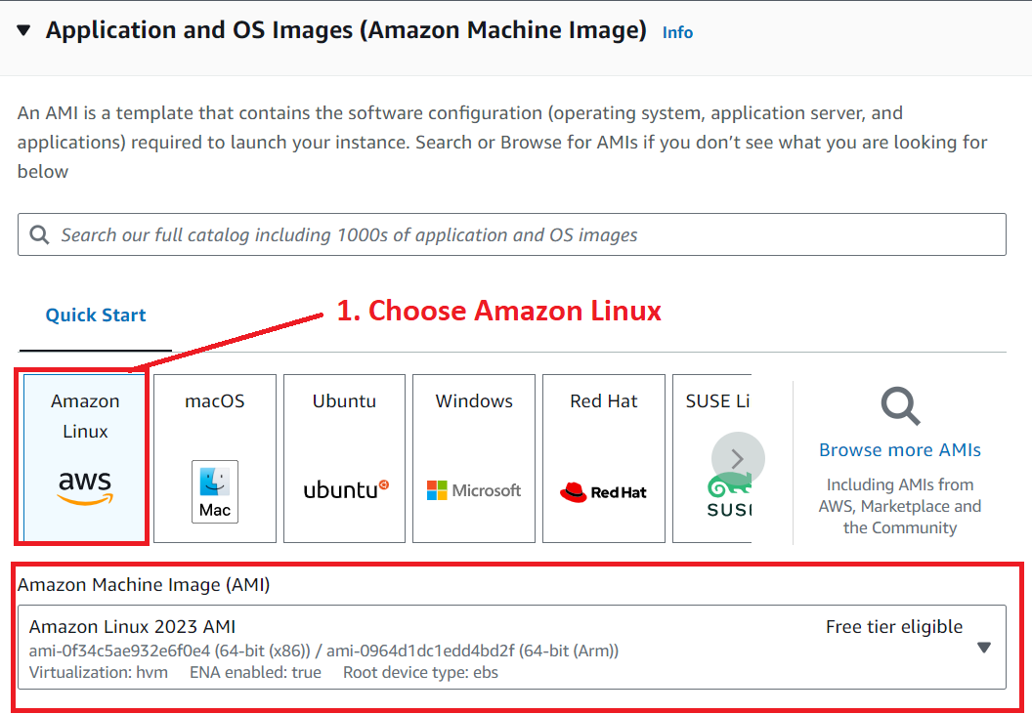

**Step 5: Choose Instance Type** as **“t2.micro”** & **Key pair name** as **“Proceed without a key pair (Not recommended)”.**

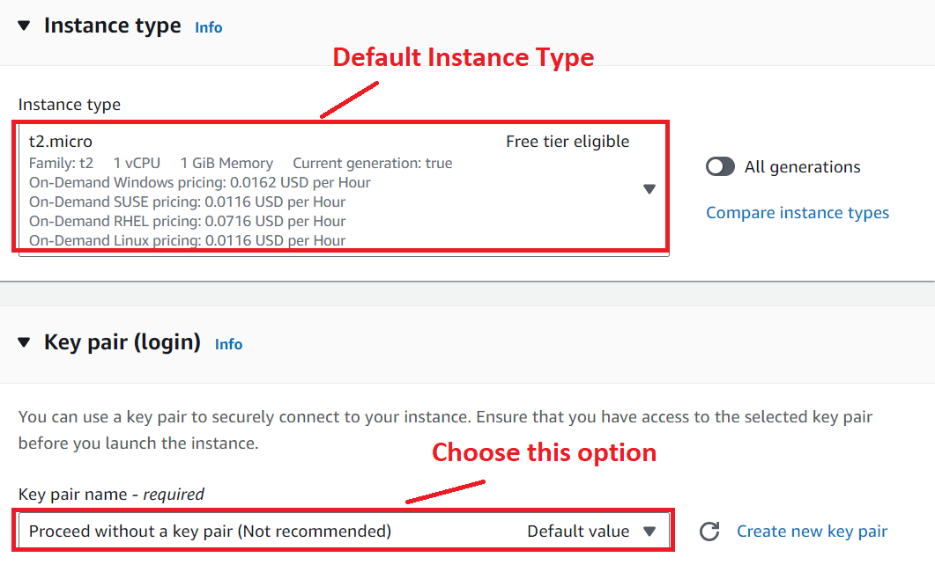

**Step 6: Remain “Network Settings”** as **by default** & **Choose “Allow HTTP traffic from the internet”.**

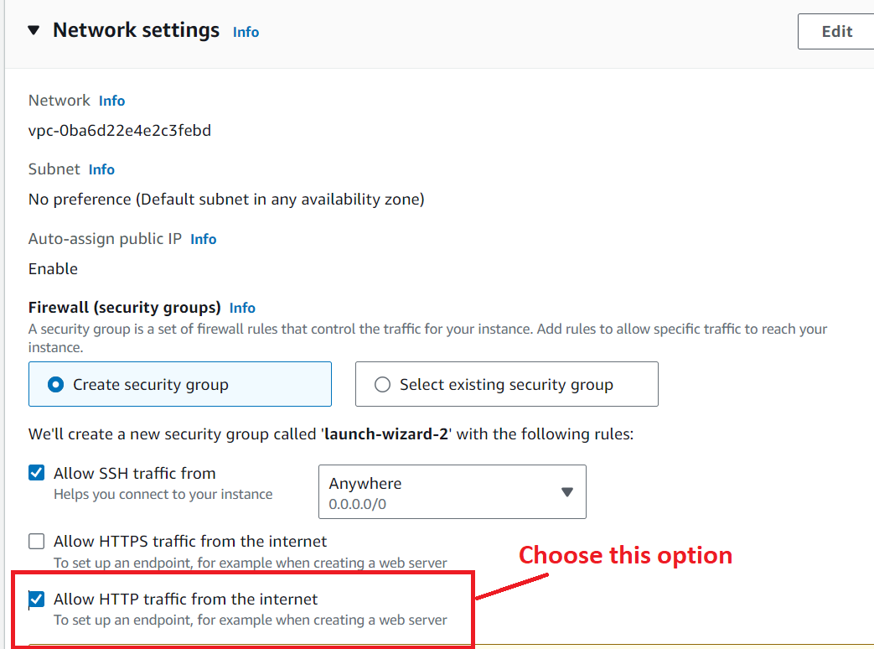

**Step 7: Remain other settings as it is & click on “Launch Instance”.**

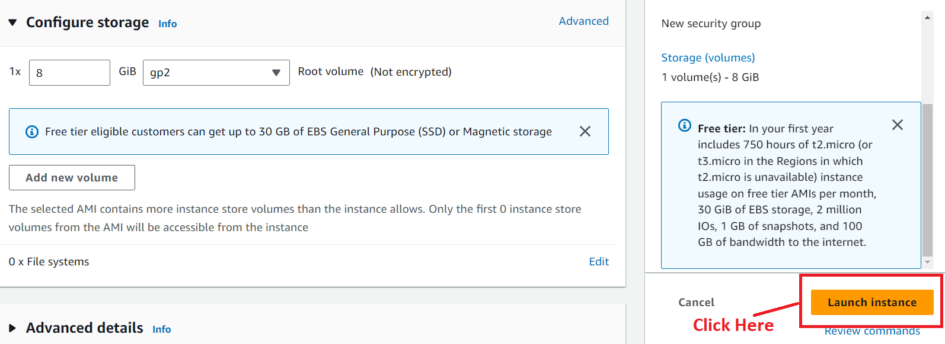

**Step 8: Instance will be successfully launched. Click on “Instance Id” starts from “I”. (Instance Id: i-01c2a678c688755e3).**

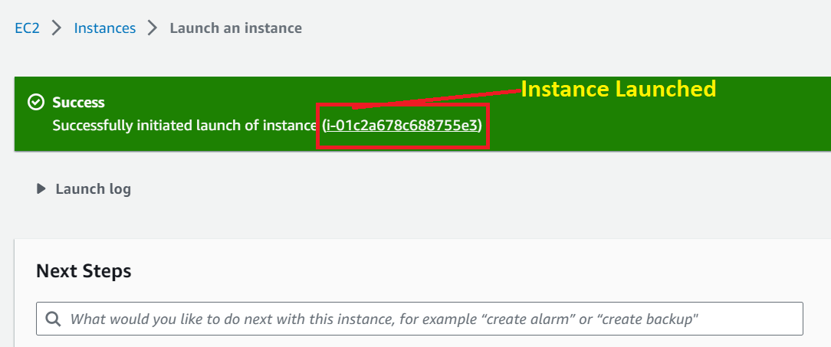

**Step 9: Your instance will be in running state like this;**

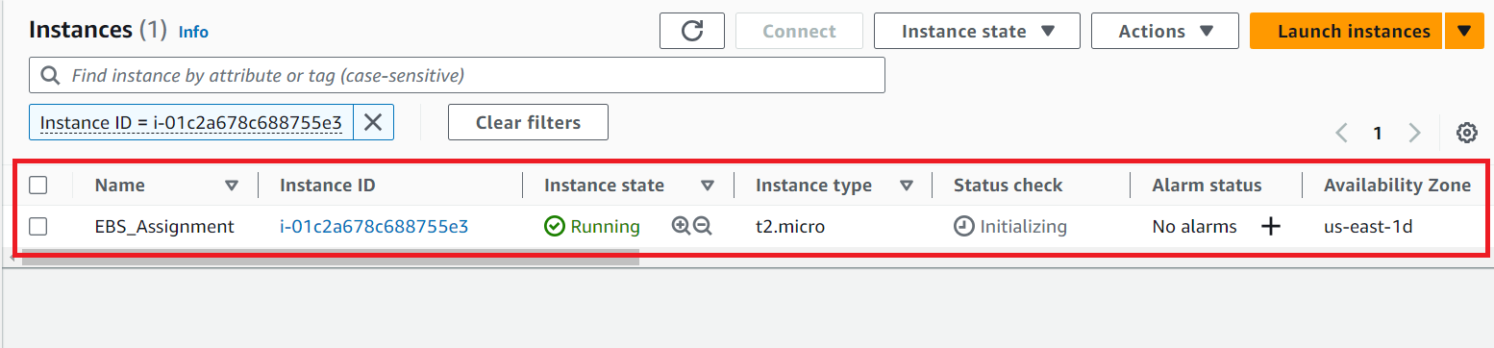

**Problem 2 Solution:** Create an EBS volume with 20 GB of storage and attach it to the created EC2 instance.

**Step 1: Go** to **Elastic Block Store>Volumes.**

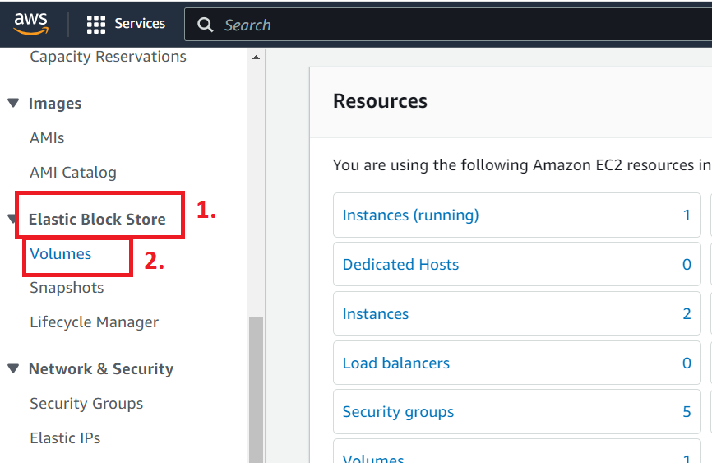

**Step 2: Click** on **“Create Volume”.**

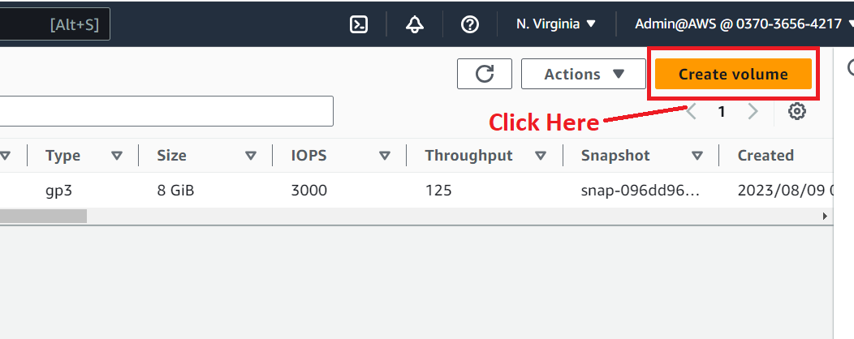

**Step 3: Go** to **Volume Settings, Choose Size (GiB)** as **20. Our EC2 instance** is in **us-east-1d, choose Availability Zone** as **“us-east-1d”.**

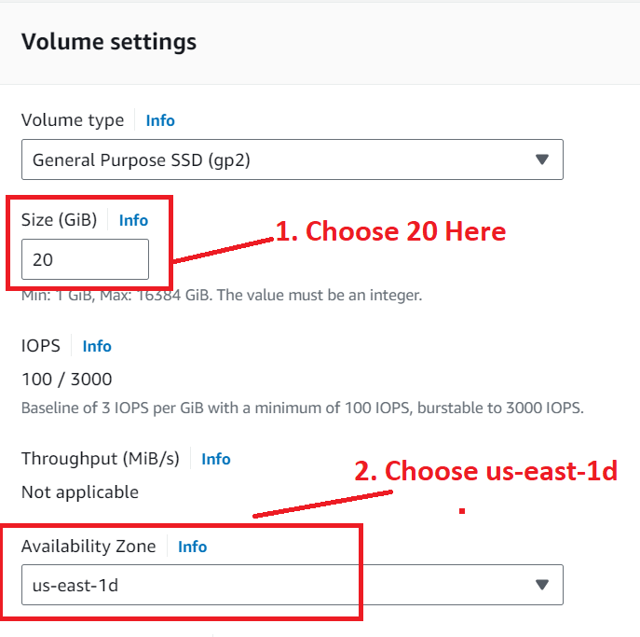

**Step 4: In Tags, choose “Name”** as **“EBS Assignment”. Click** on **“Create Volume”.**

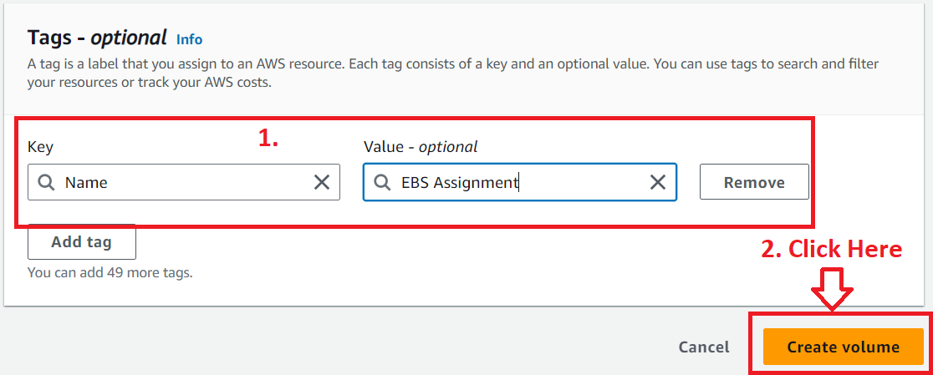

**Step 5: Now, volume will be successfully created.**

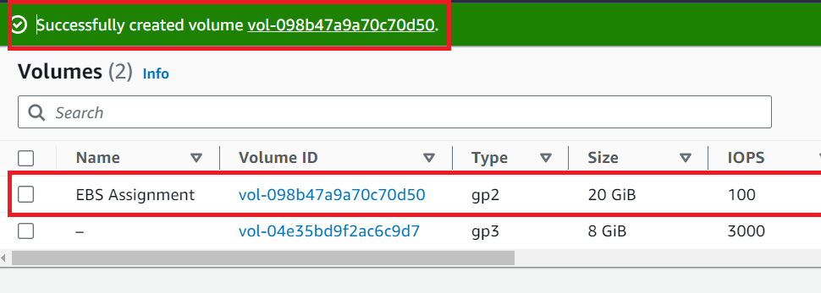

**Step 6: Now, select the EBS Volume.**

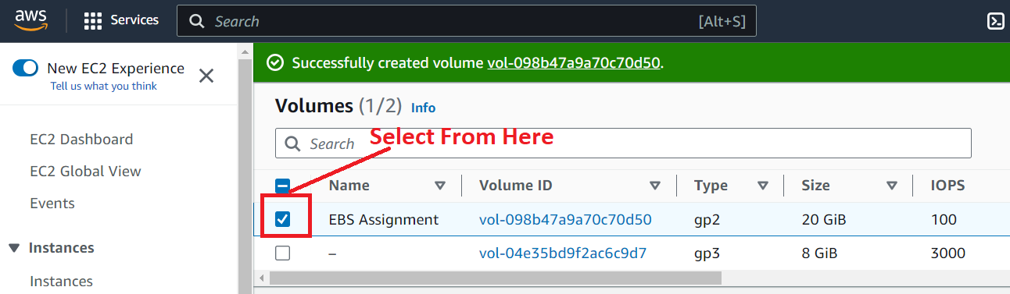

**Step 7: Go to Actions>Attach Volume.**

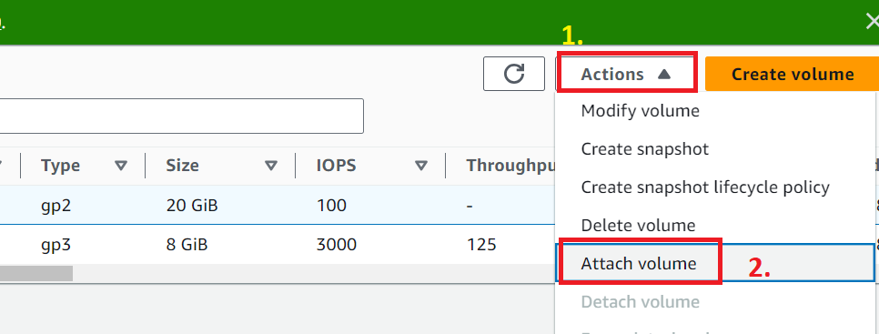

**Step 8: Choose your Instance** & **Click** on **Attach Volume.**

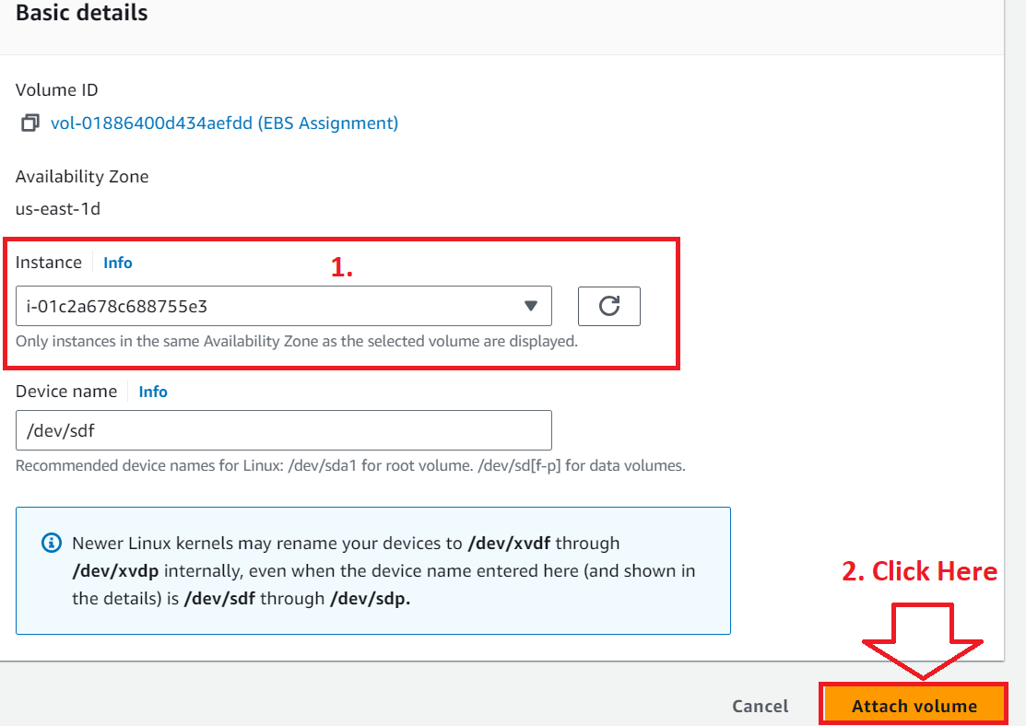

**Step 9: Your volume** will be **successfully attached to the “EBS Assignment”.**

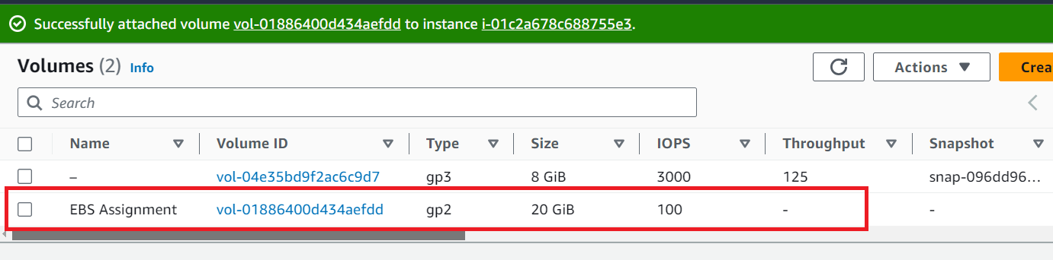

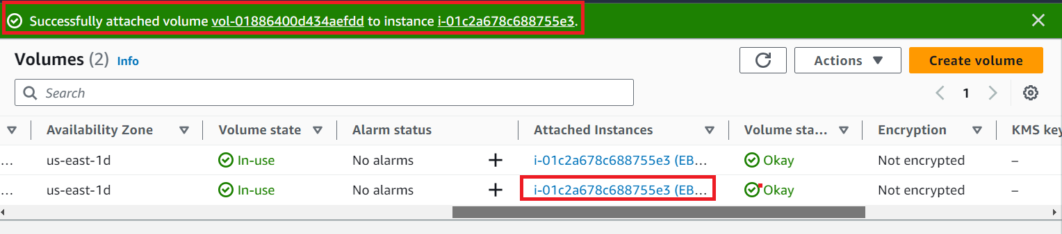

**Step 10: Go** to **“EC2 Dashboard”** for **viewing** the **attached volume. Click** on **Instance.**

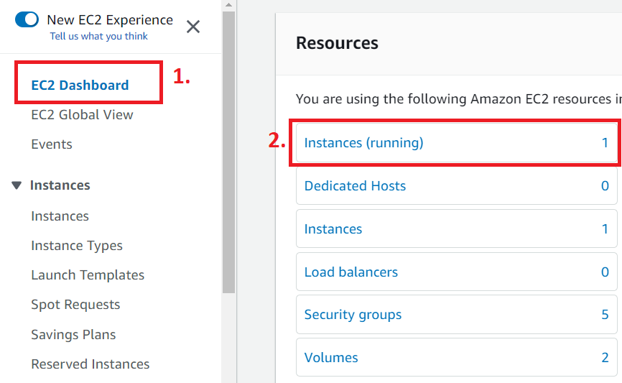

**Step 11: Select** the **Instance** & **Go** to **Volume. You** can **view** your **attached volume** with **20 GiB size** here.

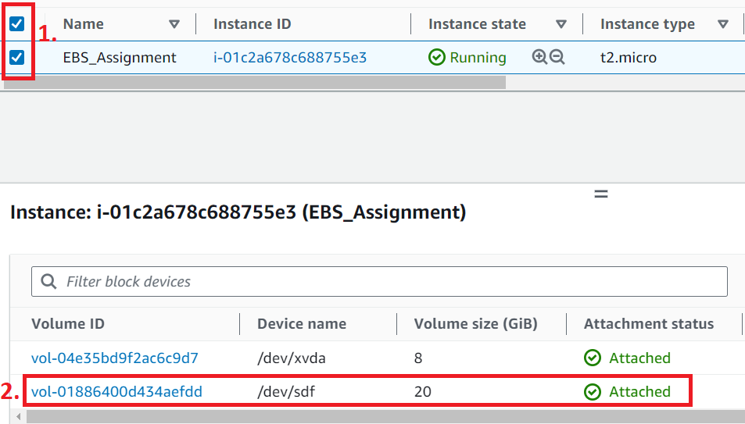

**Problem Solution 3:** Resize the attached volume and make sure it reflects in the connected instance.

**Step 1: Go** to **Elastic Block Store>Volumes.**

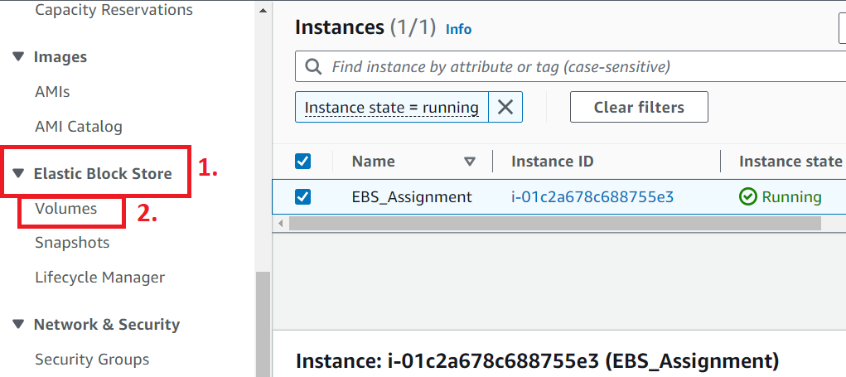

**Step 2: Choose “EBS Assignment”** volume**. Go** to **Actions>Modify volume.**

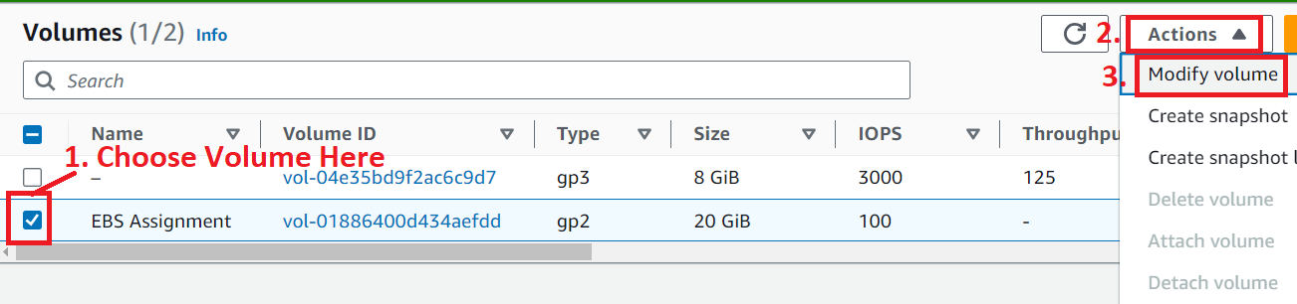

**Step 3: Now, we** will **modify** the **Size** from **20 GiB** to **30 GiB. Click** on **“Modify”.**

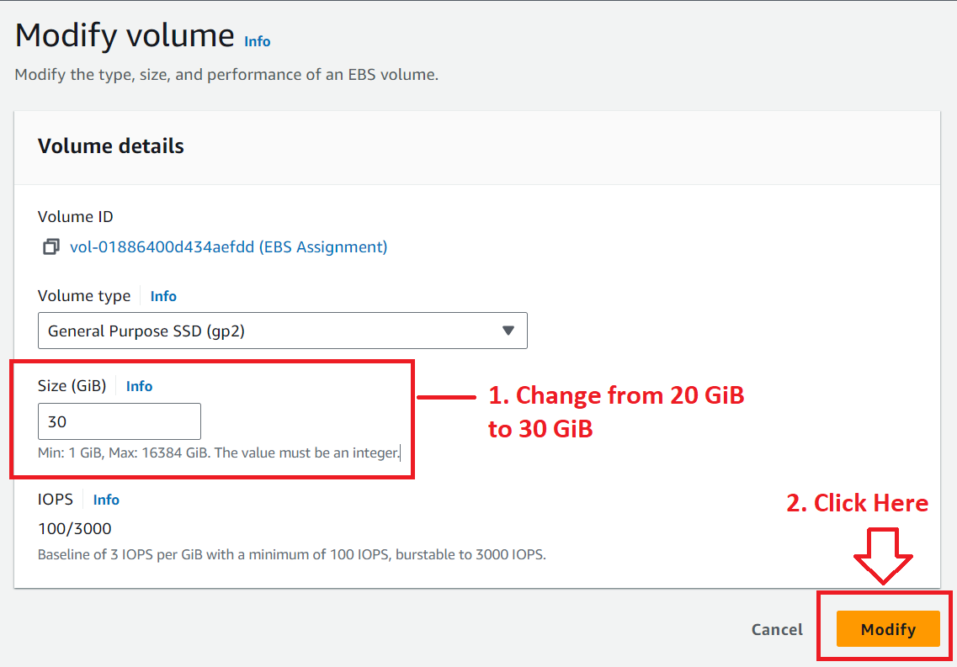

**Step 4: A pop** will be **opened** & **click** on **“Modify”.**

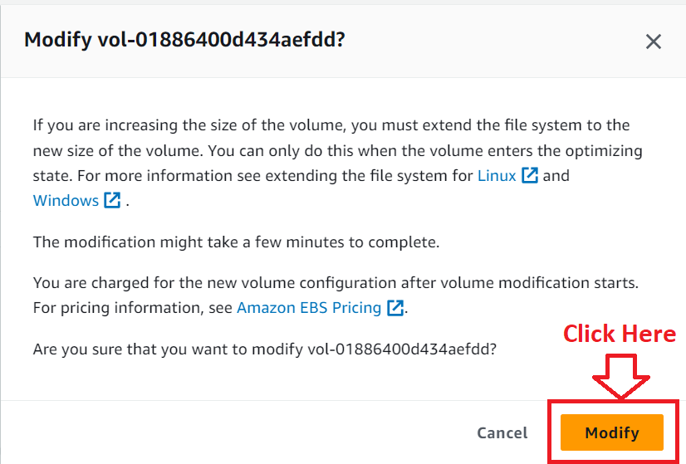

**Step 5: A modification message** will be **shown** as **“The volume is being modified”.**

**Note: Modification will be taken sometime. It will not change immediately.**

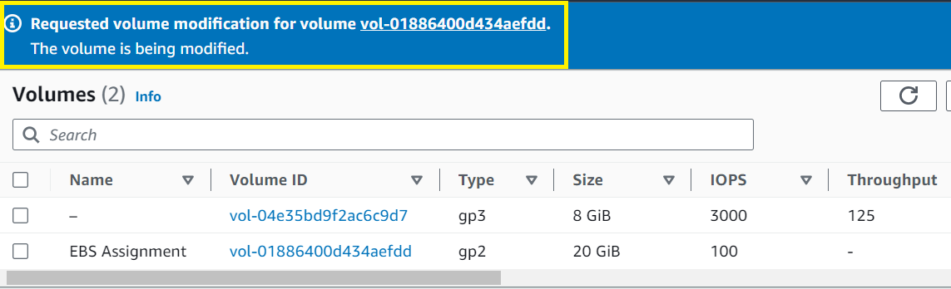

**Step 6: Refresh the browser & you will see the modified volume size.**

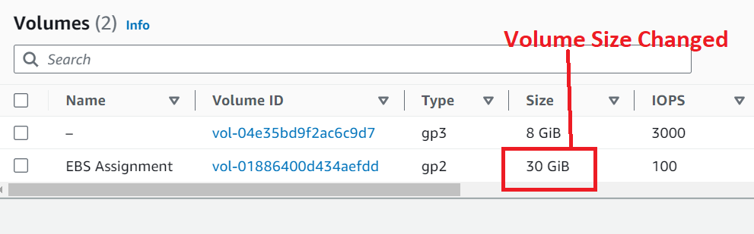

**Step 7: Go** to **“EC2 Dashboard”** for **viewing** the **attached volume. Click** on **Instance.**



**Step 8: Select** the **Instance** & **Go** to **Volume. You** can **view** your **attached volume** with **30 GiB size** here.

